AWK SCRIPT
NAME : ENIYA B A
CLASS : CSE – A
ROLL NO : 230701085
4.A.) EMPLOYEE AVERAGE PAY
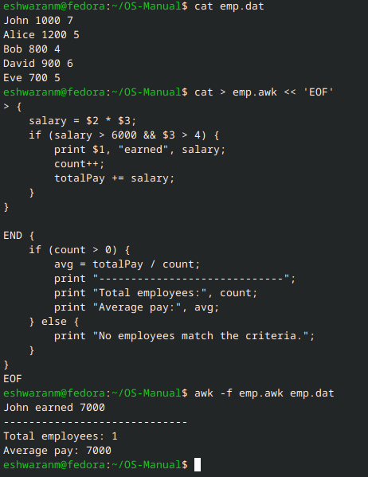

4.B.) RESULTS OF EXAMINATION
